Kolkata Mary Ward Social Centre
Lotus Child Project
Free Eye Check-up Camp

Date :- 17/11/22
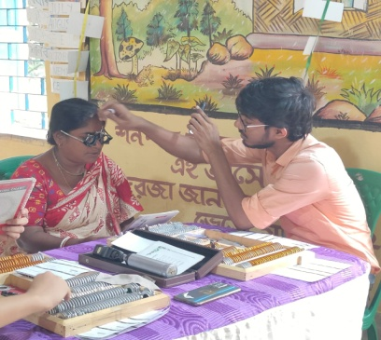
Day:- Thursday
Venue:- Chaulgola
Members visited from office to conduct the camp –Pouspi Talukder and Sr. Rosita
Community Teachers – Khokan Haldar, Rebati Paik, Rina Gayen
Members from VRX –and Syed Alfred
An Eye check-up camp was initiated at Chaulgola centre by the Lotus Child Project team. It was an initiative for the community members who suffer from vision problems in collaboration with GKB – Vision VRX. It was a free eye check-up camp organized where the community members can check their vision and get the prescription at free of cost. Since after a certain age the vision of people usually gets blurred, the community members were very interested to join the camp. Their frames were also decided according to their features of face and the spectacles will be given to them within two months. Ones recommended with cataract operation will be connected to the hospital where they can continue their operation free of cost and in good hands. The whole program was conducted by them free of cost and along with the check-up there will be no further charges for the frames, glasses, and operation. The camp was quite successful and was benefitting for the people.
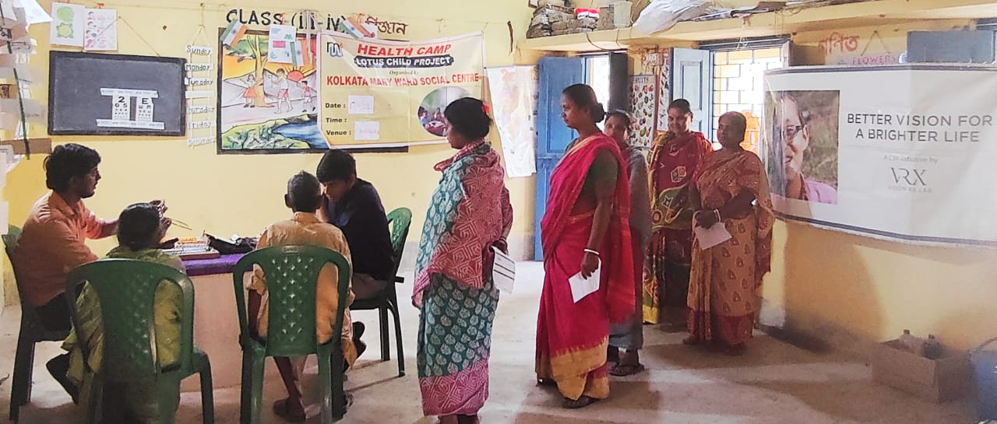
Thus to support their program lunch was arranged by the lotus child project team under the health program for these members conducting the camp and the members supporting it along with . Car was also hired for the day for the project team and eye camp team for travelling.
