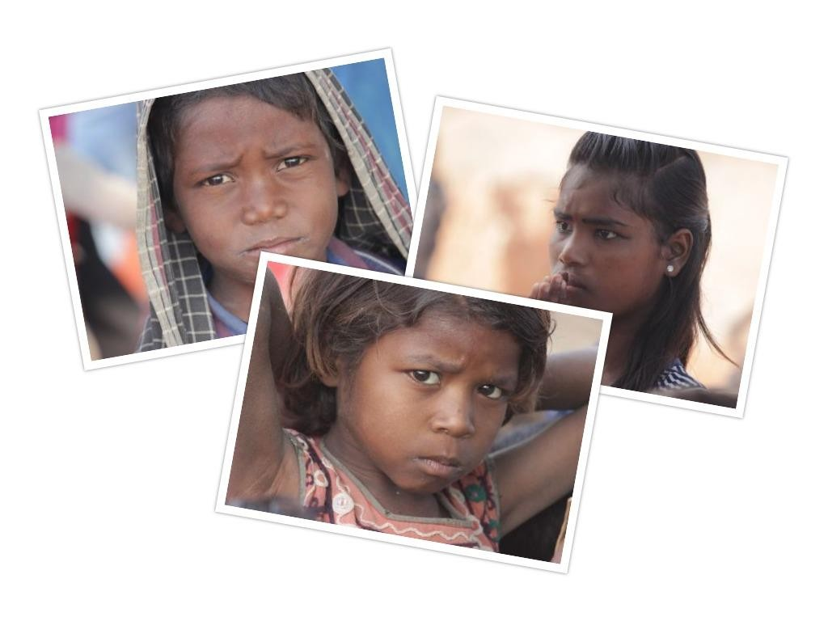

October-December 2019

Quarterly Newsletter

Kolkata Mary Ward Social Centre

1, Convent Lane, Tangra, Kolkata-700015, West Bengal, India
The Community vigilance committee is been given orientation of the function of the VLCPC in each of their village. The VLCPC as stated earlier Village Level Child Protection committee is a statutory body where elected representatives along with civil society form the groups.
The CVC groups are now alert over the Excessive use of mobile phones by their wards, step up VLCPC functioning, seeking for adult literacy measures from the village legislative committees and reminder of not giving their girls in marriage and stressing on career building for them.

Total no of meeting: 25

The Adolescent girl’s group meetings are the core to this project. Once they were informed, the girls made a difference. Girls are intellectual enough to make a difference in their own life as well as in the lives of their peers. These meetings boost encouragement and influence them and the community they live in.
These 3 months the POCSO law was discussed with them. POCSO or The Protection of Children from Sexual Offence Act (POCSO Act) 2012
The girls were oriented about Village Level Child protection Committee (VLCPC) and how they could influence this committee through the local village governance.

Total no of meeting: 20

ANTI-HUMAN TRAFFICKING PROJECT

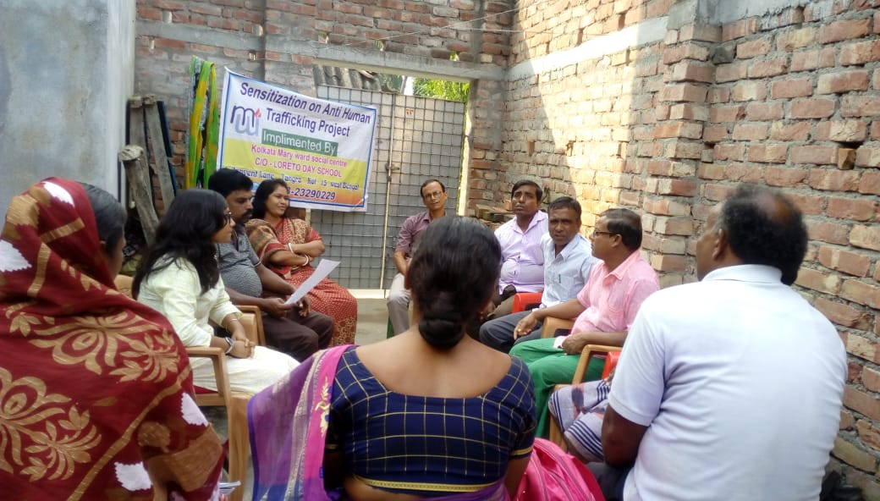
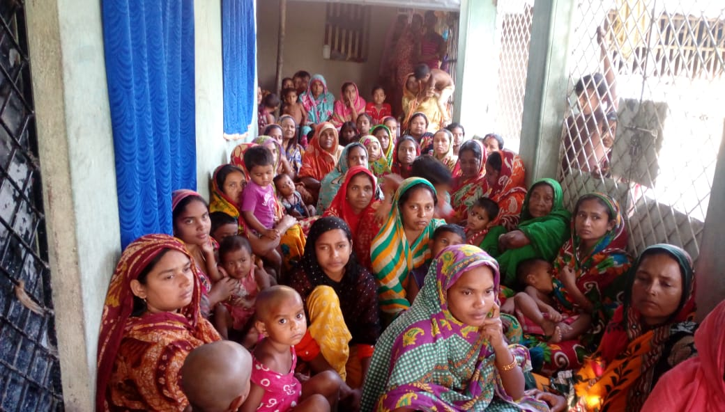
Child friendly village Steering Committee meeting
The meeting passed resolution for better awareness meeting in every street corner of the village and market areas
They also decided to have awareness materials distributed to every home of the villages
They also made resolutions that information of child line and child rights matter be displayed at every prominent places of the village for knowledge of the villagers

Meeting on Model Village:
- Organising of meeting different areas of the village of Debisabad
- Finding out who are the child representative in the VLCPC of the
- Meeting with village Panchyat about the Migration register of the village
- Matters of child Marriage and Child Trafficking

Total no of participants: 55

Total no of participants: 55

RED LIGHT PROJECT

Direct Beneficiaries: | Indirect beneficiaries:
Children of SW’s and high risk (6 to 18 years)  No. of Direct Beneficiaries- 80 | The overall communities not directly connected with the project, but will still benefit from it, through sensitization programme like auto campaigns, puppet show and street drama.
SW and high risk prone women of the community
No. of Direct Beneficiaries- 30
Club Member
No. of Direct Beneficiaries- 10- 15
Community people
No. of Direct Beneficiaries- 150
Adolescent Children
No. of Direct Beneficiaries- 10

Awareness generation in the community and especially among CSW mothers through personal meetings, Auto campaign, puppet show, theatre for development and focused group discussions on various issues

Case Study

32 year old Sonia (name Changed) lived in the brothels of red-light area where her mother who was a sex worker left her. Other sex workers in the brother raised her and wanted to push her in the trade but she ran away and married a man from red-light where she lived as his wife and earned her living by ironing cloths. Her husband is a alcoholic and now wants to leave his driver job seat at home and drink. Hence the husband is forcing Sonia to join the trade as she denied to do so he started abusing her physically and mentally. Recently when her husband beat her so badly that she had to have 8 stitches on her head the project staff intervened and motivated her to file a FIR against her husband. Her husband was arrested. She is still continuing to earn her living from ironing cloths. (She has 3 children one is at hostel and 2 children coming to our centre)

BRICKFIELD SCHOOL PROJECT
Brick field schools new session started from 4th November 2020

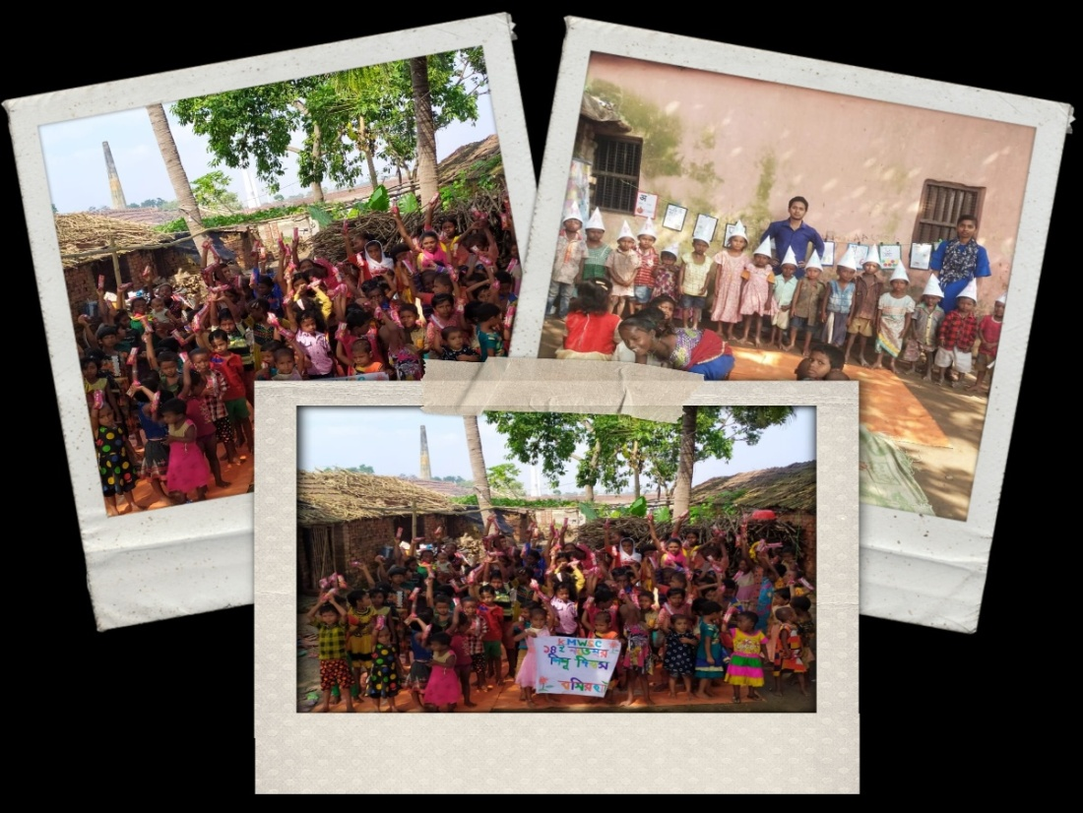

A Worth celebration of birthday with the Migrant Children

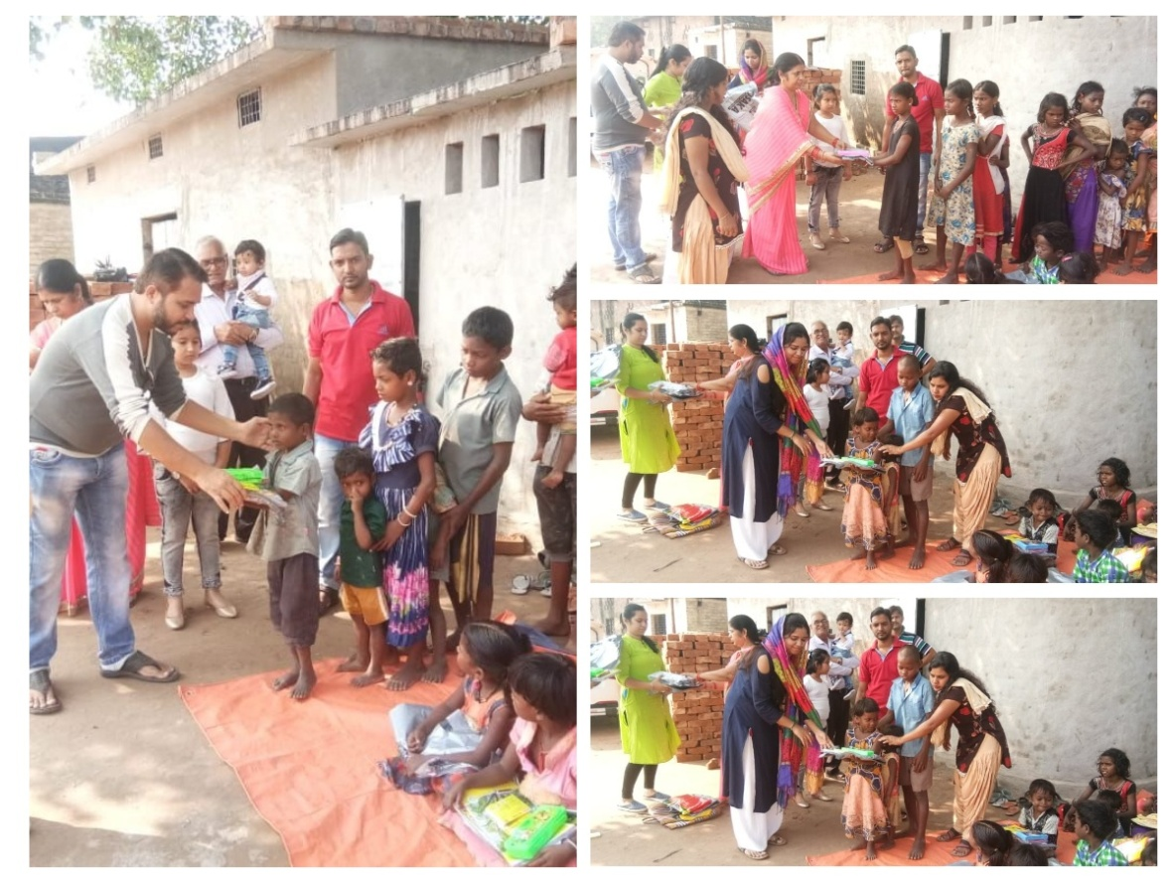

BAREFOOT TEACHERS TRAINING PROJECT

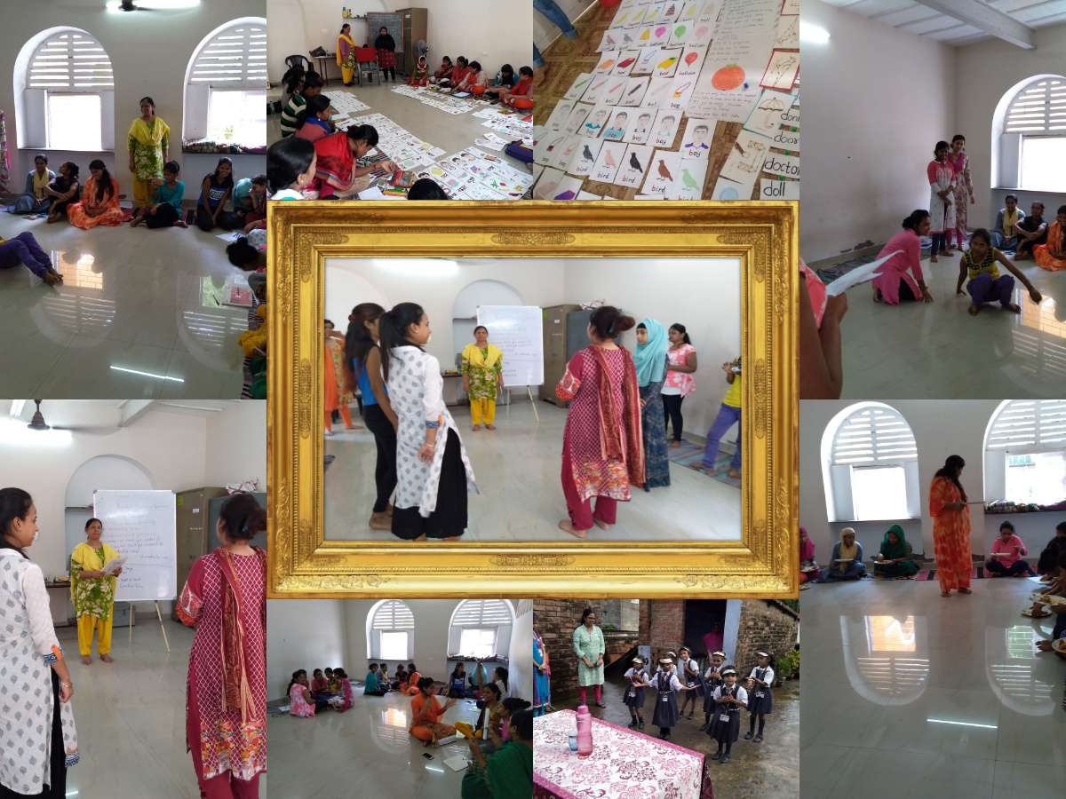

LODHA PROJECT

CELEBRATION AT THE PROJECT

SOLAR PROJECT

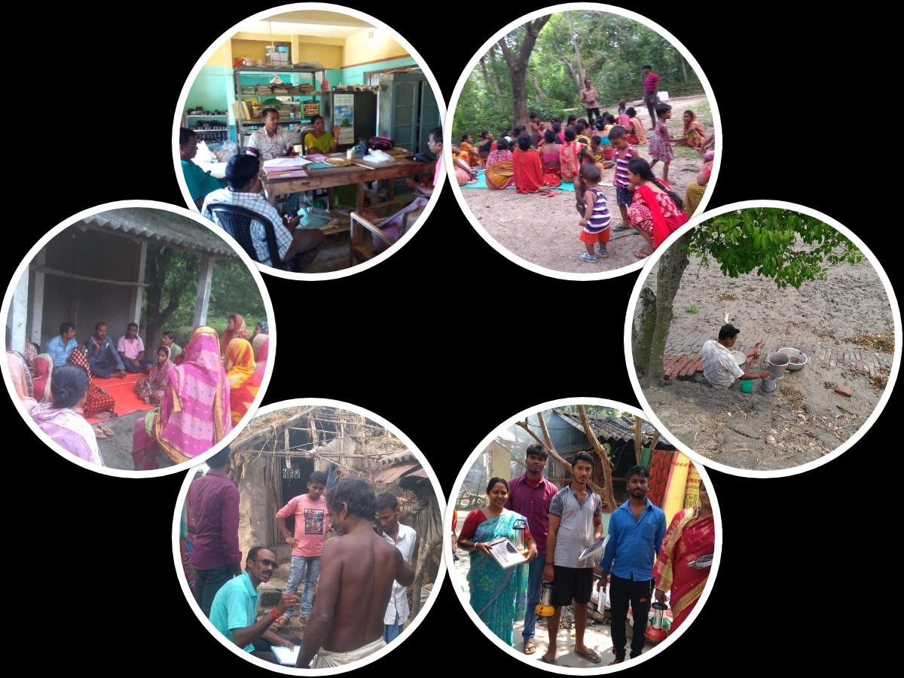

CHILD RIGHTS PROJECT

SKILL DVELOPMENT PROJECT
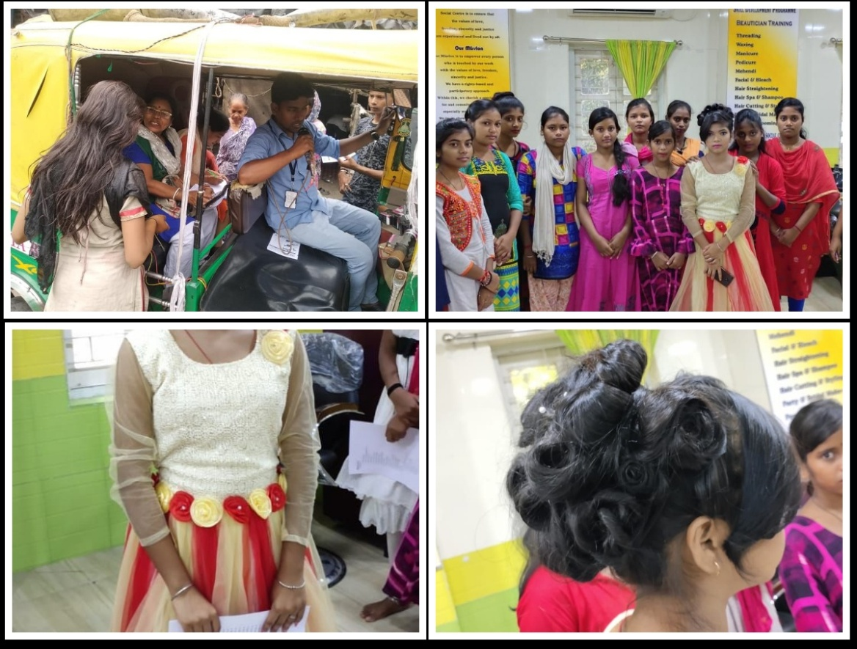

LOTUS CHILD PROJECT
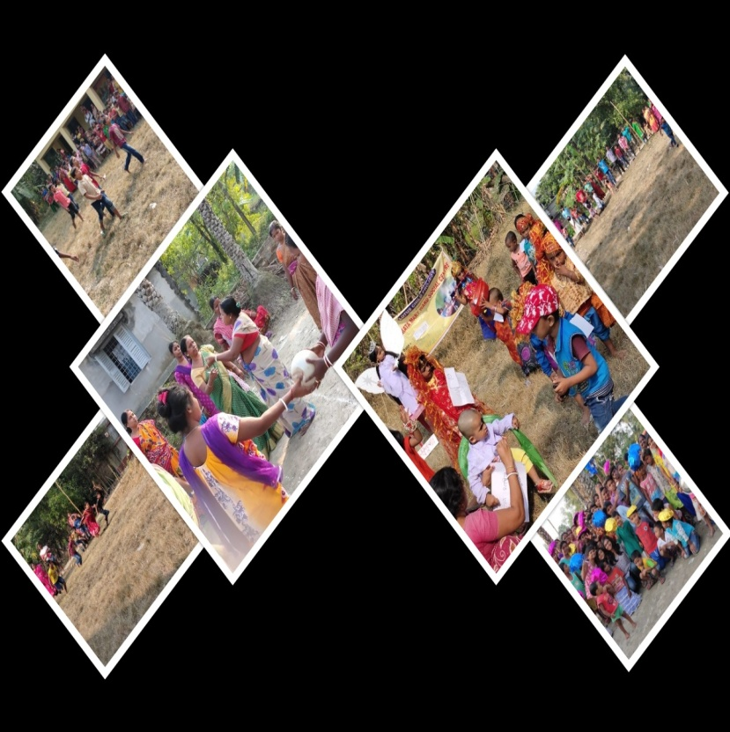
Sport’s Day
Lotus child Project organized Sport’s Day at both the place Sonapota and Chaulgola
Children of both centre from the sub juniors group (i.e 7 years and below) participated in biscuit race and go as you like, the junior children. 8 – 12 years participated in spoon race and math race. Above 12 years and peer group children participated in role on game and also in speech competition. There was a game ball passing for only adult community members of Sonapota centre.
There were almost 90 children along with adults at Sonapota and 140 children at Chaulgola participated in the sports competition at their centre

Exposure Visit
72 Children from Sonapota and Chaulgola centre along with 8 staff went for exposure visit at Bakkhali. The whole program was conducted by Lotus Child Project. The children and the staff altogether gathered at Namkhana Railway Station along with Project coordinator at 8am and reached the destination at 10am. On the way to Bakkhali they had their Breakfast in the bus. After reaching Bakkhali they all visited the 4 places which are very famous like Henry Island, Frazergung, Bhagawatipur, for crocodile Project, and Mousumi Dam. During this visit they came to know each other and also interacted with the project coordinator. During the sightseeing they played different types of games and activities. For them it was a great experience and learning because they literally don’t go out. The children enjoyed a lot and they praised KMWSC director and projector coordinator for organizing a beautiful event.

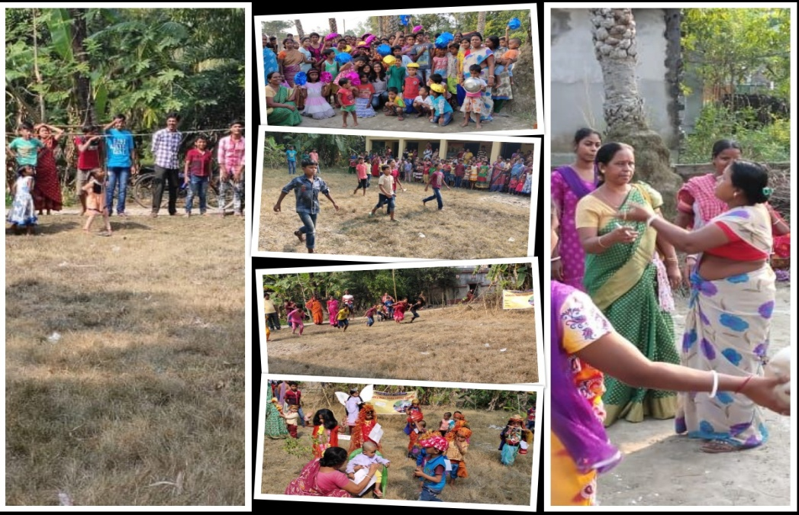

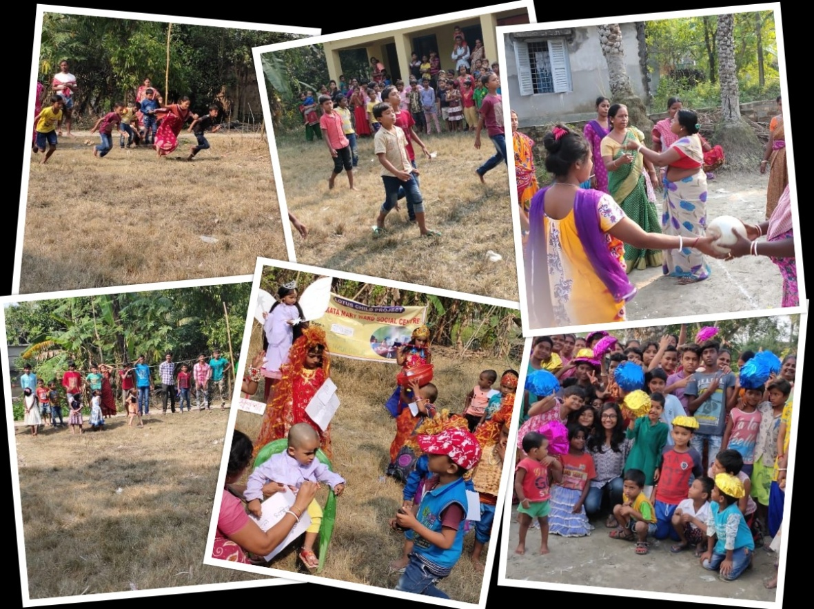

Auto Campaign

The campaign was a mass communication method of spreading the awareness regarding the Vocational training, like- Beautician, Tailoring, Bakery, Spoken English and Computer Training. People gathered and informative leaflets were distributed. 35 people entry his or her name for the training

Child Group Meeting

That day we discus to health and hygiene and also discuss to what is child labour and child marriage. Child rights also discuss there. Told that must be awarded to be child marriage and child rights.

TRAININGS

Orientation cum training program of child right's program for Caritas NGO partners of West Bengal was conducted in Seva Kendra Siliguri

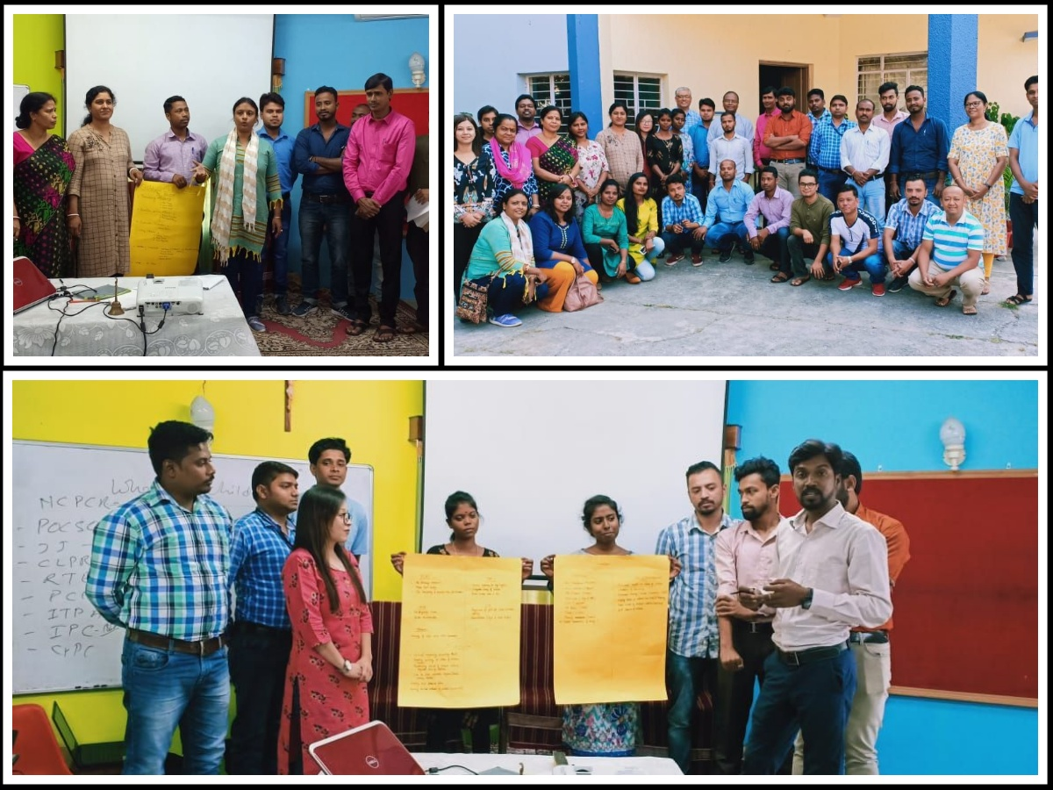

Follow up workshop by Mr Khilesh Chaturvedi on project log frame and decision making format

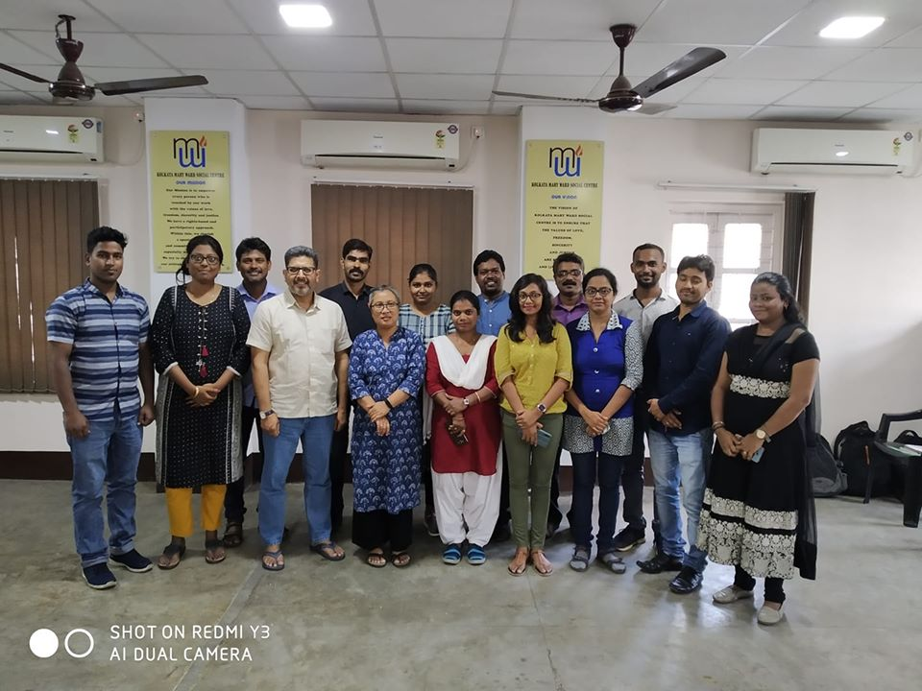

VISITORS

Gifts from Schools

Staff Retreat 2019! The time of relaxation, refreshment and fun. It was a great to have time set aside for us as staffs to connect one another. Thank you Sr Monica Suchiang, the director of KMWSC for giving us the lovely time of togetherness

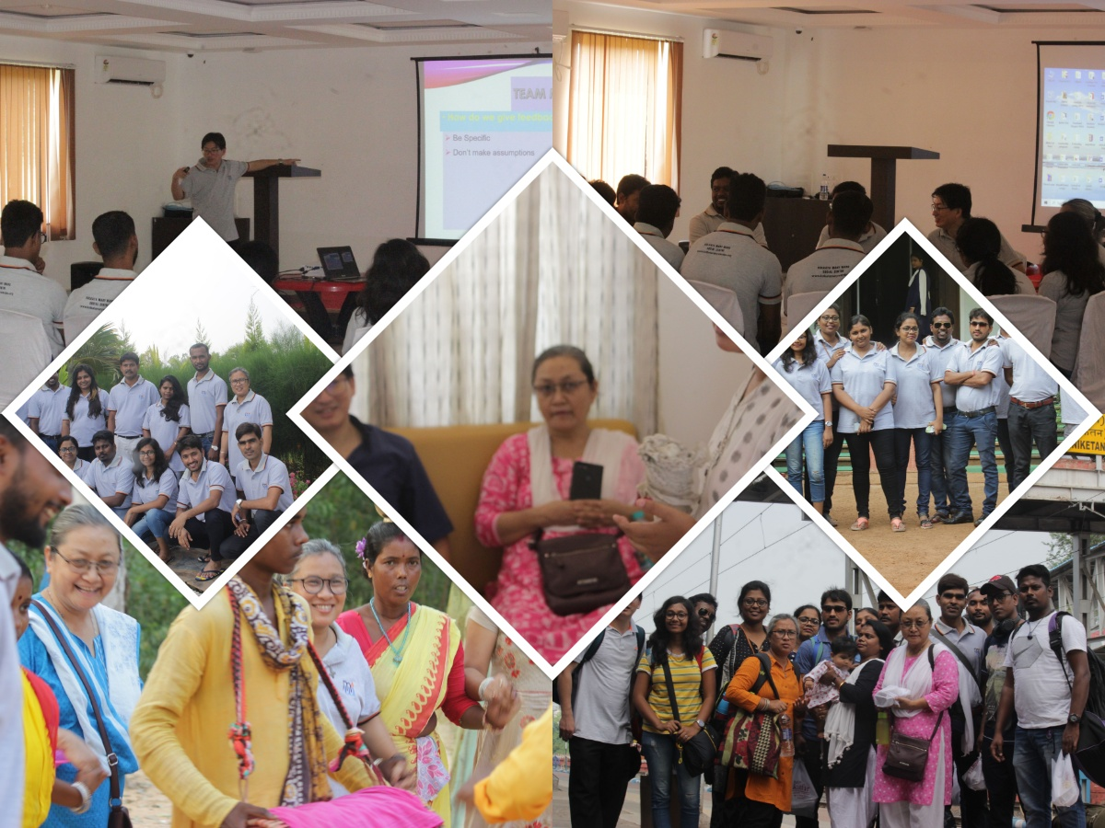

Children Day Celebration in different projects

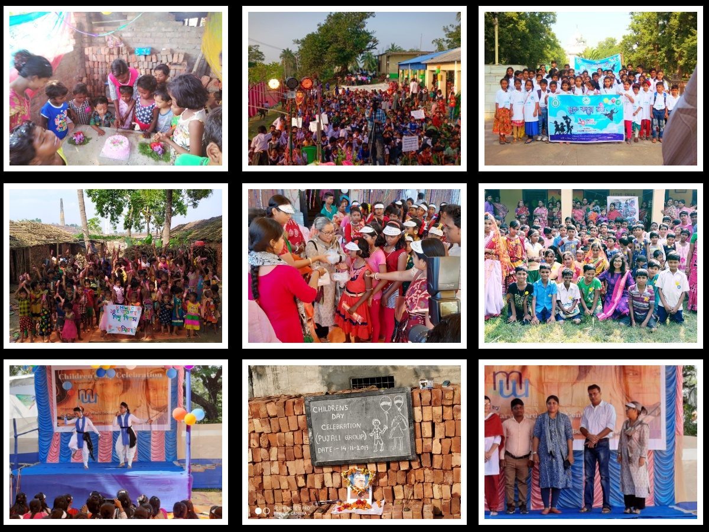

Thanks for being with us in our efforts of making this world an inclusive and safe place for all children....making them heard and valued

\

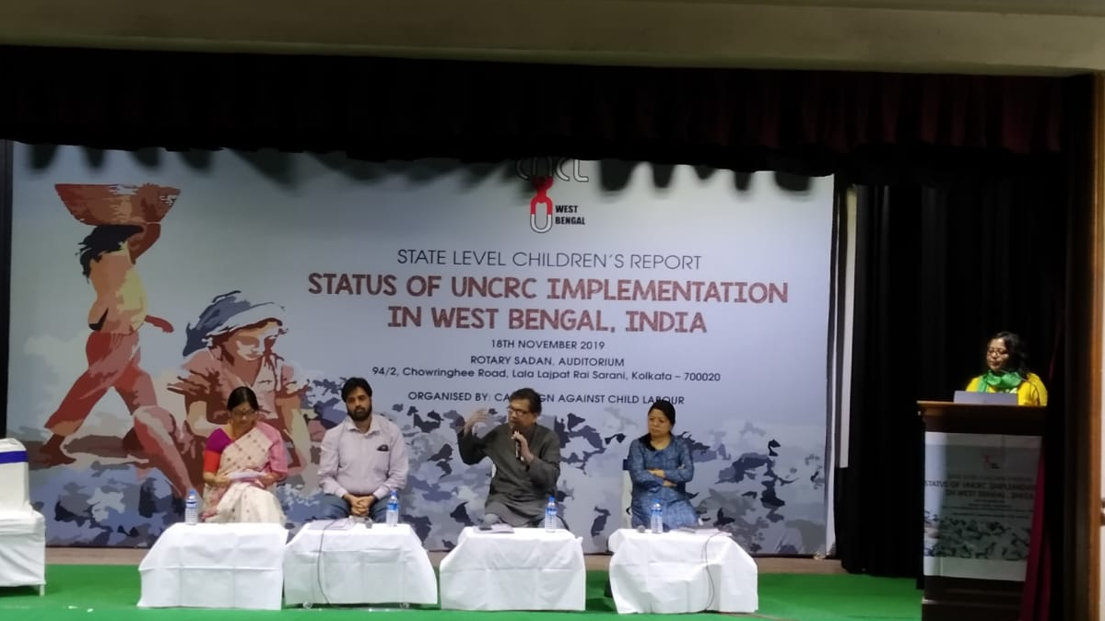

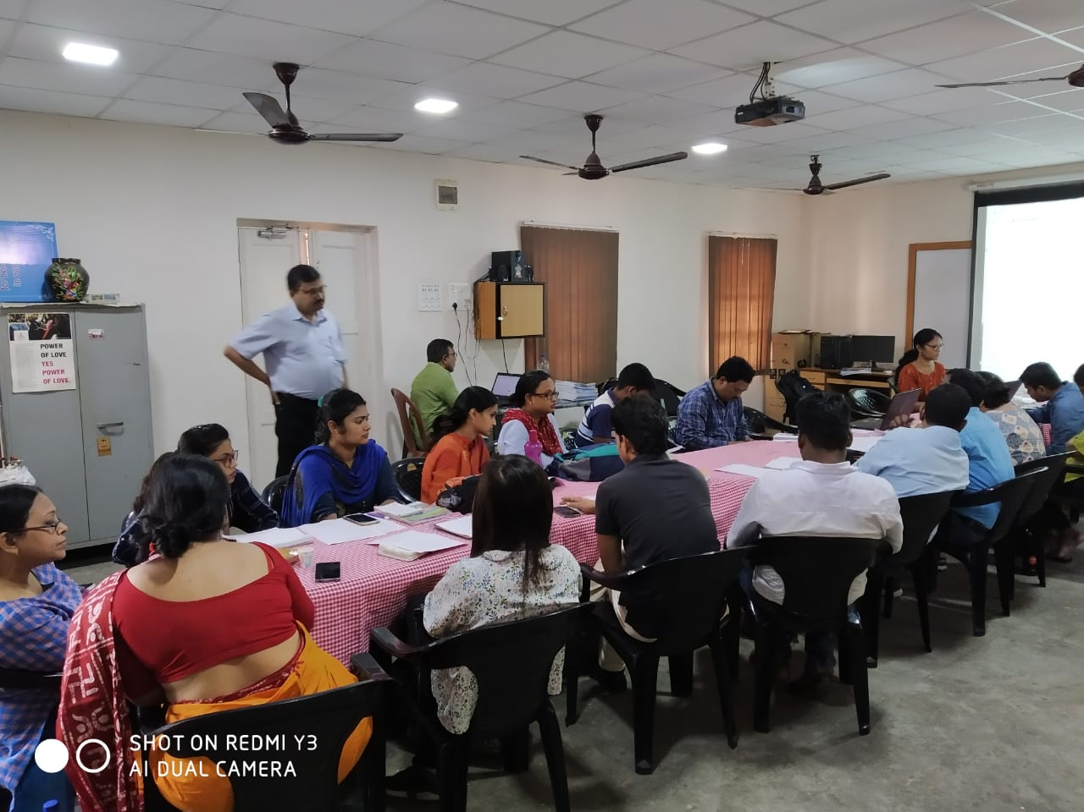
Kolkata Mary Ward Social Centre was the core member of CACL workshop on official release of report on UNCRC at Rotary Sadan in front of the government and different NGO officials. Glimpses of state dissemination on children alternate report on UNCRC
The advocacy coordinator facilitated CACL workshop on official release of report on UNCRC at Rotary Sadan in front of the government and different NGO officials. Glimpses of state dissemination on children alternate report on UNCRC

KMWSC facilitated West Bengal Chapter on Child Labour under the banner of CACl. There were 23 participants from different NGOs. Akhil is appointed to collect case studies from the field. Advocacy with different Government stakeholders were discussed on topics and questionnaires. CACL meeting on child labour mapping tools which will help us to get the data from government officials in our respective projects areas.

Glad to announce the launch of the Cafe & Bakery unit of KMWSC. At the initial stage, Loreto sisters were helped financially by GOAL for purchasing the machines. Mr. Chakraborty helped in setting up the unit. Since its inception, the bakery slowly but gradually expanded with the demand of production. Earlier, the students of the school were taught home science in the bakery. Later, baking classes were given to women for improving and developing their skills in this art and market their baked goodies.
The bakery started to flourish and became an integral part of the Skill Development Program for the organisation. In 2016, Christmas cakes were only baked. With the years by, KMWSC got new ovens and machines and now each year they bake almost 300 to 400 kgs of cake only during the Christmas season. Apart from the baking and the baking classes, students were initiated and are placed at different first class confectioners and hotels. This year KMWSC took a further step and have launched a new venture of Cafe & Bakery. The Anglo Indian Member of Legislative Assembly West Bengal Mr. Shane Calvert, and Loreto South Asia Superior Sr. Sabrina Edwards inaugurated the Food ATM while Seva Kendra Kolkata Director Dr. (Fr.) Franklin Menezes blessed the Cafe & Bakery venture at KMWSC. Other dignitaries present at the event were Vice Chairman of the Minority Commission, West Bengal, Rtd Justice Nadira Patheria, Mrs Ananya Chakraborty, chairperson of WBCPCR, Sudeshna Roy, member of WBCPCR and Dr. Joydeb Majumdar, Director of Jaypraksh Institute of Social Change, religious and priests, NGO members and well wishers. The inaugural function was concluded with high tea prepared from the Bakery and Cafe including cakes, puffs and deserts.

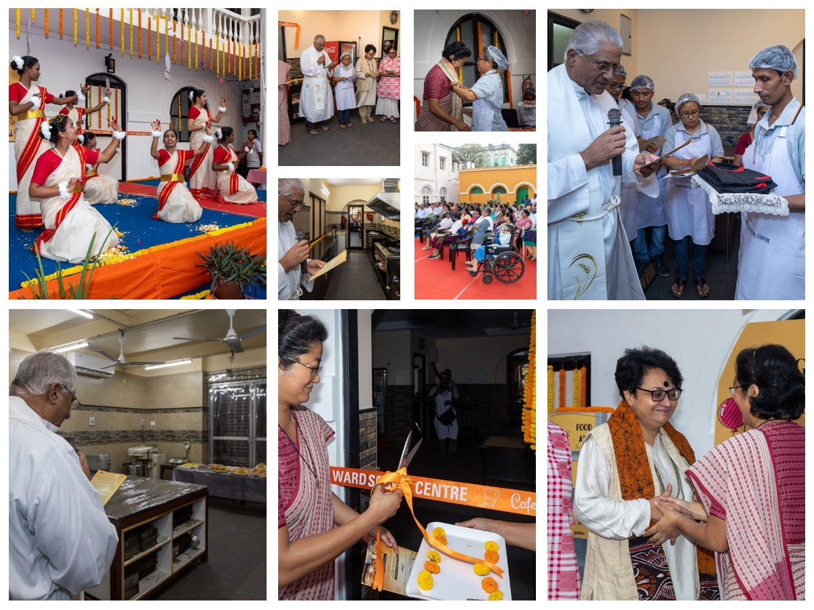

FOOD ATM

Loreto Sisters in Kolkata have come up with a new and generous concept to serve the poor – Food ATM (Food Any Time Machine). “In 1909 this very concept was used to serve food to the needy in Motijheel and Entally,” says Director of Kolkata Mary Ward Social Centre (KMWSC) Sr Monica Suchiang. Thus this is rather a revival of the initiative that was taken by the Loreto sisters. The Anglo Indian Member of Legislative Assembly West Bengal Mr. Shane Calvert and Loreto South Asia Superior Sr. Sabrina Edwards inaugurated the Food ATM while Seva Kendra Kolkata Director Dr. (Fr.) Franklin Menezes blessed the Food ATM installed at KMWSC premises, 25 November 2019.
Speaking at the inauguaration KMWSC Food ATm on 25th November 2019, Sr Monica graduated of National Law School Hyderabad spelt out her vision for KMWSC through its 3 thematic approaches on Protection of Women & Child Development, Education & Health and Community Develop through Livelihood & Skill Development. She also added that the main motive behind this revival was for the needy people of Entally.

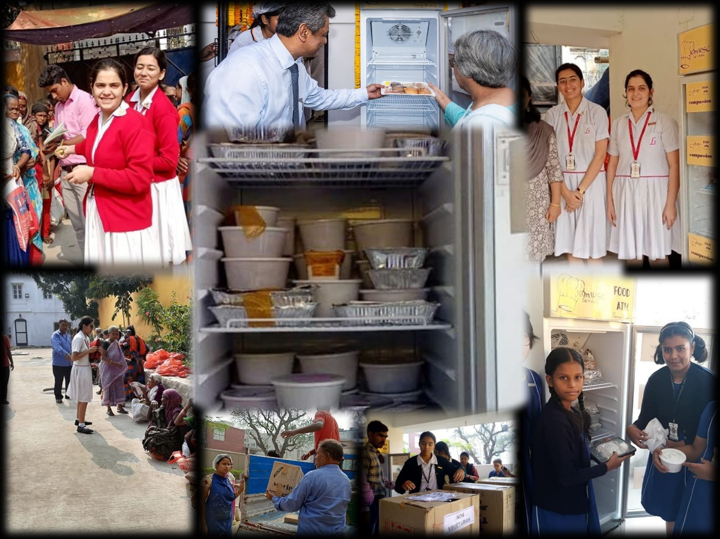
Thank you for your contribution towards Food ATM
- Loreto School, Entally
- Loreto School, Elliot Road
- Loreto School, Bowbazar\Loreto Residence, Sr Beatrice, SR Angela Rodrigues, Sr Claire
- Mrs Gini George, Principal of Loreto School, Asansol
- Justice Nadita, Rt Judge of Kolkata High Court
- Lucky Roy, Creaive Artist

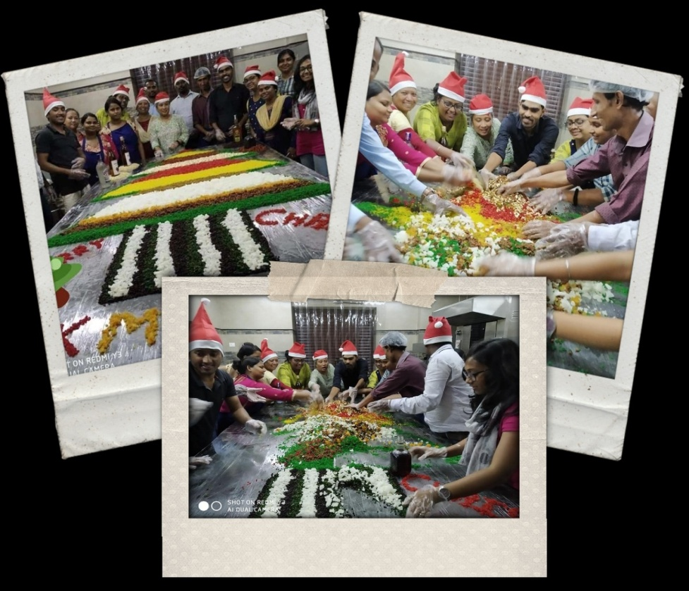

Festive Spirit:

The cake mixing ceremony is a warm up to the festive holiday season, it does much more than just that. Today, the age-old ceremony of cake mixing was observed in the Kolkata Mary Ward Social Centre bakery with the director and staffs. It was indeed a moment of joy and togetherness

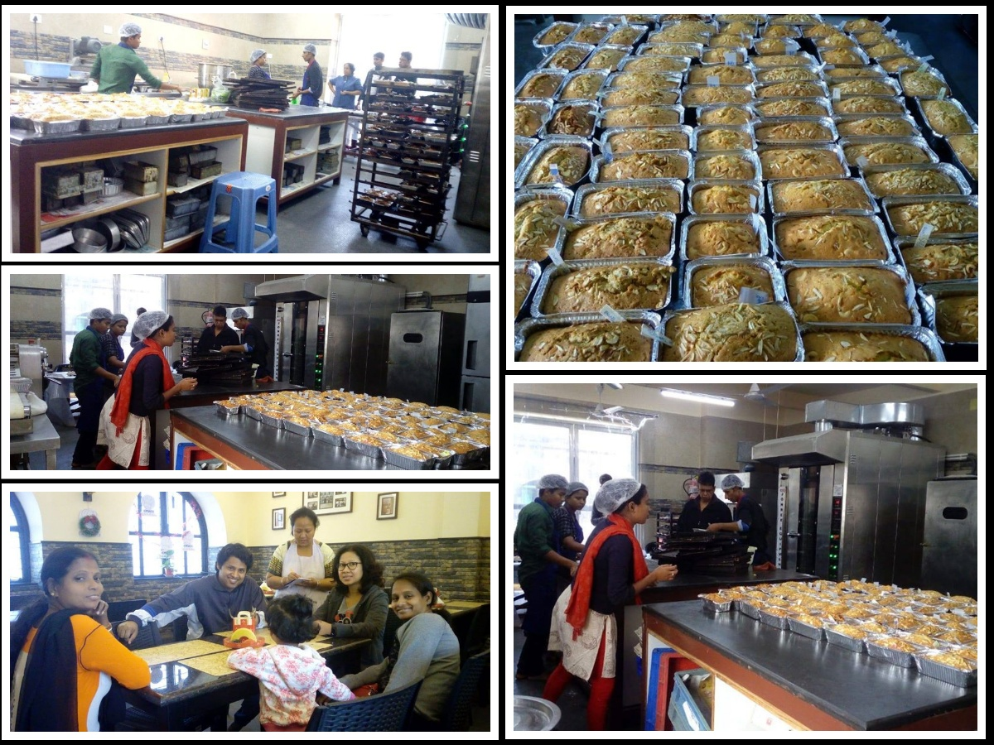
Christmas time! A family time to cherish!

Families, schools, NGOs and other officials baking Christmas Cakes with us

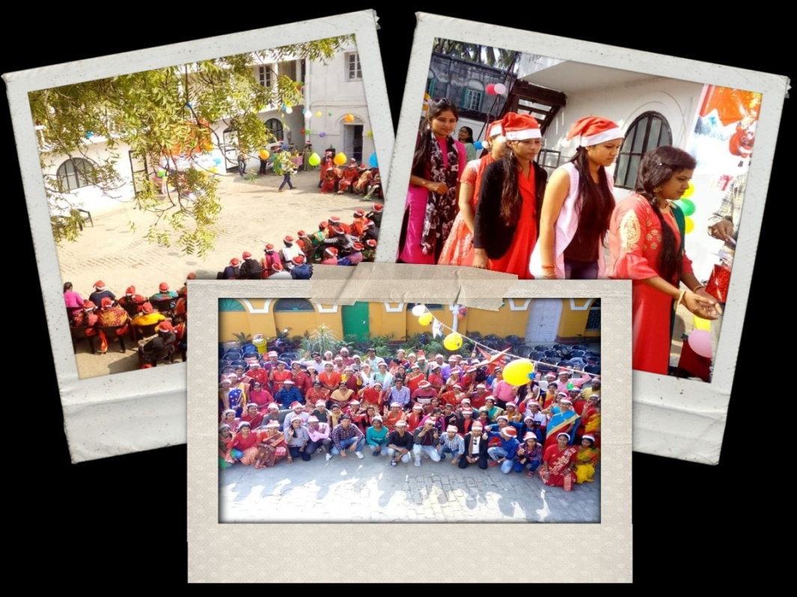
Christmas joy shared with project staffs

Christmas joy shared with KMWSC staffs

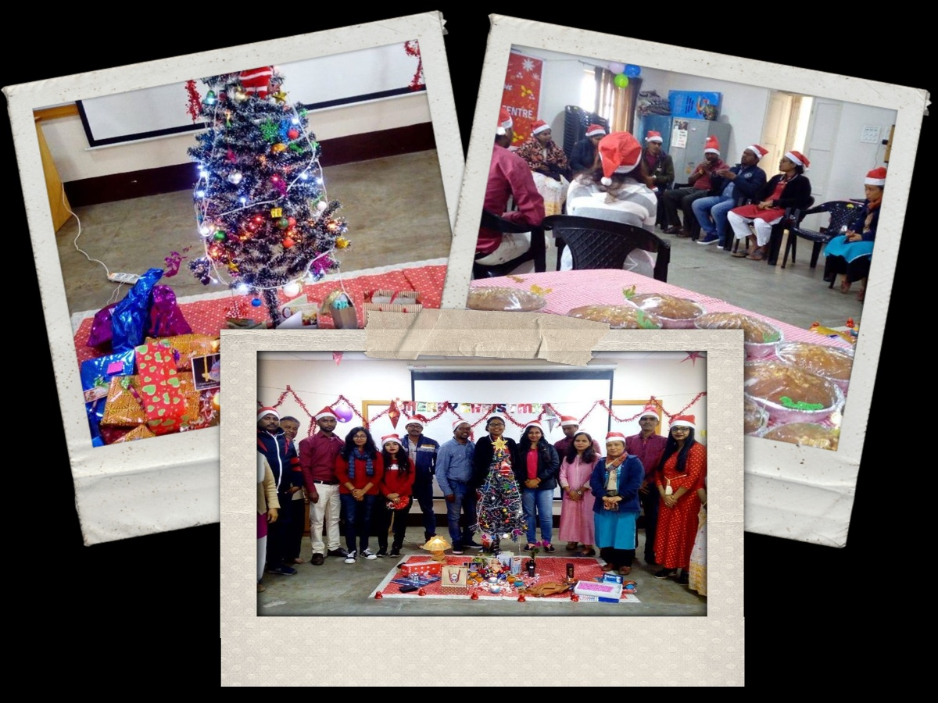

Selling bakery and café menu at the Allen Park for the first time ever by KMWSC

